STRR DEMONSTRATION REPORT – 1
Seed to Harvest
Details Of Farmer
Name of Farmers | Mahaveer Singh
Mobile No. | 6203656058
Village Name | Harnachiti
Block & Tehsil | Tilouthu
District & State | Rohtash

Field And Crop Detail
Total Acreage(acre) | 10 ACRE
Crops Grown | 10 ACRE
Field Location (Easy approach/road side) | ROAD SIDE
Selected - Crop & Variety | PADDY MTU-7029
Trial Plot Area (KATHA) | 1 acre (Including T1+T2)
Seed Rate (kg/acre) | 4 KG/ACRE
Sowing Date | 05.08.2025

Demo Product Name And Dose& Field day detail
Name of Product | SUPERRIZAH
Application Dose (ml/acre) | 2 KG
Date/Time of Application | 05.08.2025
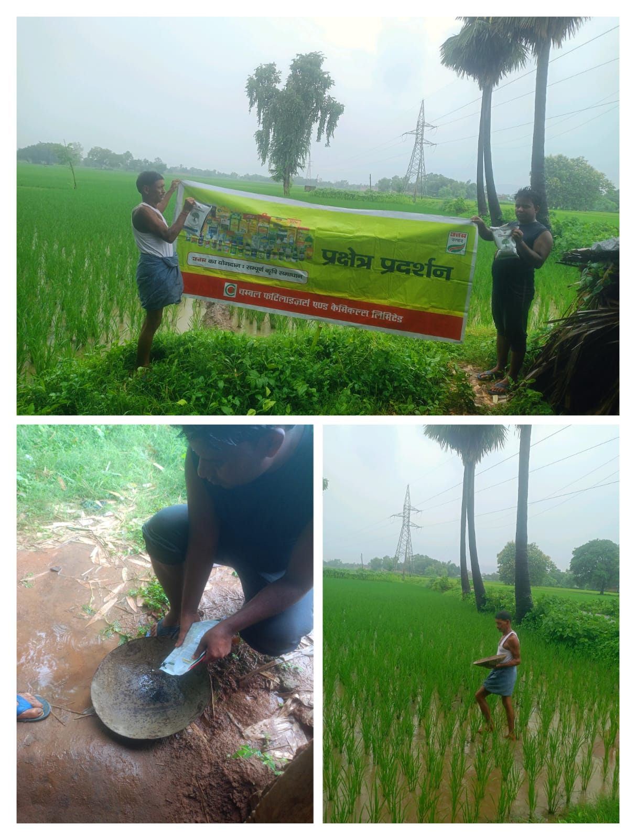

STRR DEMONSTRATION REPORT – 2
Seed to Harvest
Details Of Farmer
Name of Farmers | kapil mishra
Mobile No. | 8682045928
Village Name | Kushdihra
Block & Tehsil | Tilouthu
District & State | Rohtash

Field And Crop Detail
Total Acreage(acre) | 30 ACRE
Crops Grown | 30 ACRE
Field Location (Easy approach/road side) | ROAD SIDE
Selected - Crop & Variety | PADDY MTU-7029
Trial Plot Area (KATHA) | 1 acre ( Including T1+T2)
Seed Rate (kg/acre) | 4 KG/acre
Sowing Date | 11.08.2025

Demo Product Name And Dose& Field day detail
Name of Product | SUPERRIZAH
Application Dose (ml/acre) | 2 KG
Date/Time of Application | 11.08.2025

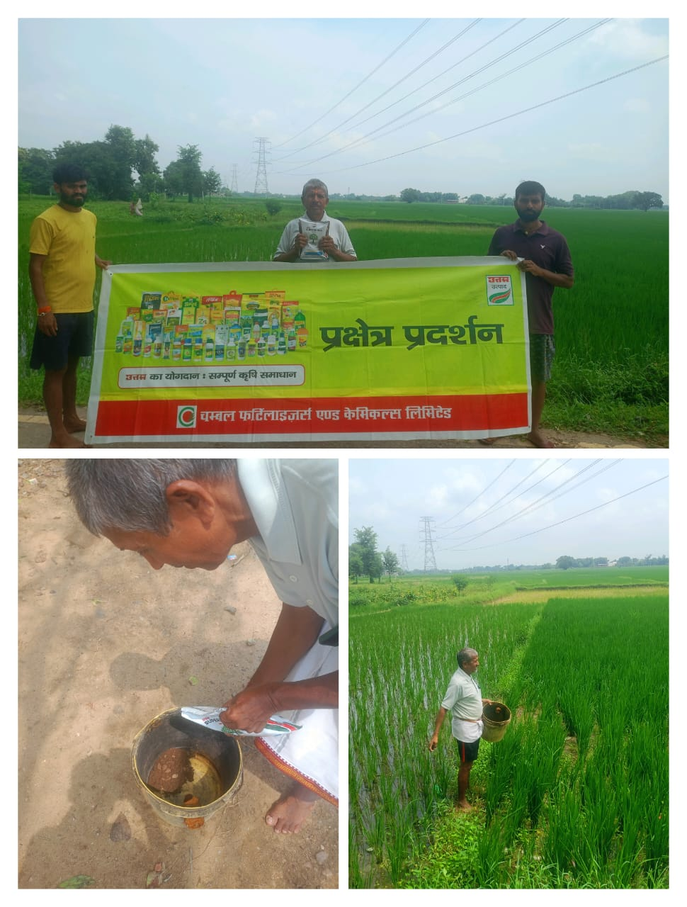

STRR DEMONSTRATION REPORT – 3
Seed to Harvest
Details Of Farmer
Name of Farmers | vinod upadhyay
Mobile No. | 82523 16459
Village Name | Sewahi
Block & Tehsil | Tilouthu
District & State | Rohtash

Field And Crop Detail
Total Acreage(acre) | 10 ACRE
Crops Grown | 10 ACRE
Field Location (Easy approach/road side) | ROAD SIDE
Selected - Crop & Variety | PADDY MTU-7029
Trial Plot Area (KATHA) | 1 acre ( Including T1+T2)
Seed Rate (kg/acre) | 4 KG/acre
Sowing Date | 11.08.2025

Demo Product Name And Dose& Field day detail
Name of Product | SUPERRIZAH
Application Dose (ml/acre) | 2 KG
Date/Time of Application | 11.08.2025

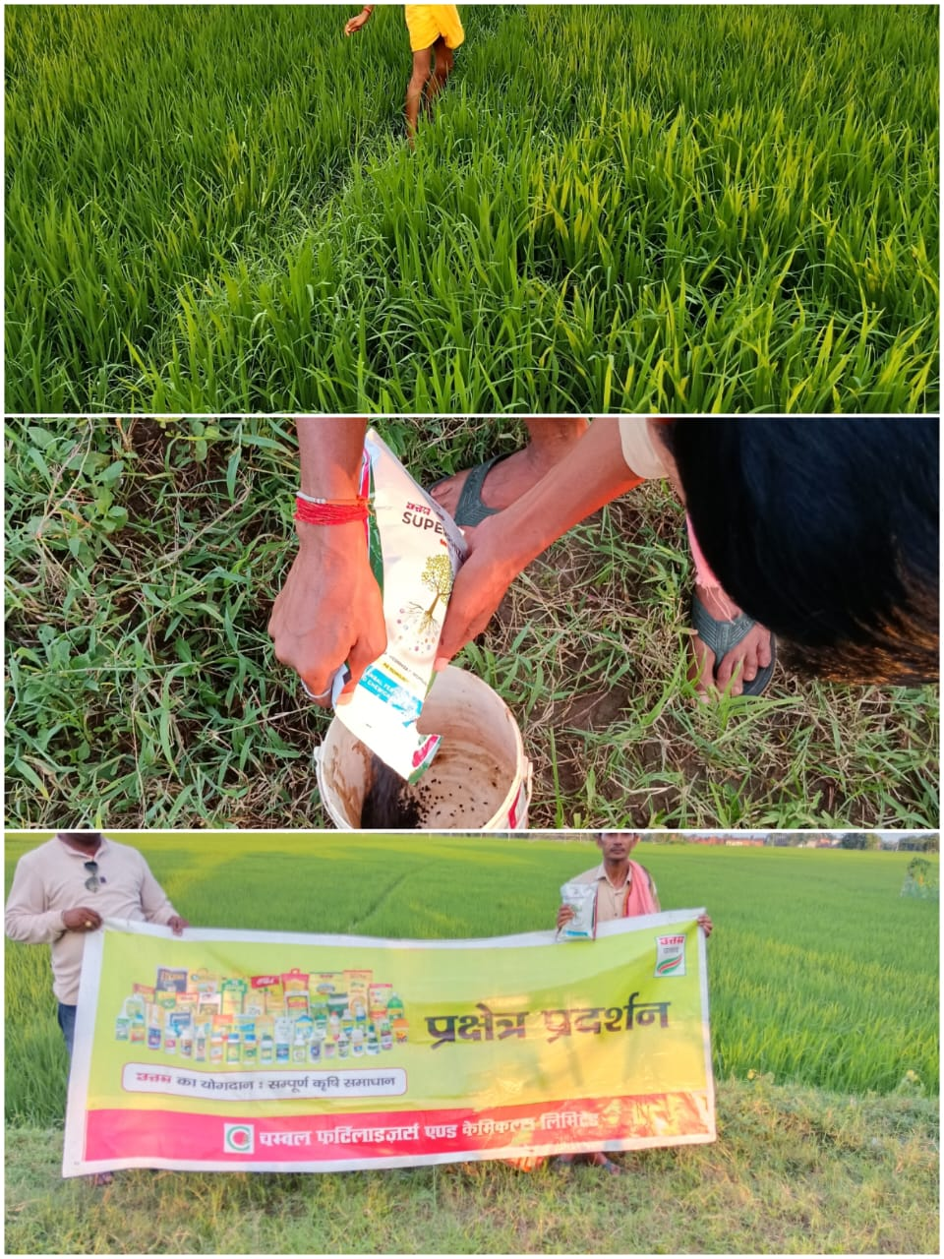

STRR DEMONSTRATION REPORT – 4
Seed to Harvest
Details Of Farmer
Name of Farmers | Sonu Singh
Mobile No. | +917903752230
Village Name | Rendia
Block & Tehsil | chenari
District & State | ROHTASH

Field And Crop Detail
Total Acreage(acre) | 15 ACRE
Crops Grown | 15 ACRE
Field Location (Easy approach/road side) | ROAD SIDE
Selected - Crop & Variety | PADDY MTU-7029
Trial Plot Area (KATHA) | 1 acre (INCULDING T1+ T2)
Seed Rate (kg/acre) | 4 KG/acre
Sowing Date | 07.08.2025

Demo Product Name And Dose& Field day detail
Name of Product | SUPERRIZAH
Application Dose (ml/acre) | 2 KG
Date/Time of Application | 07.08.2025

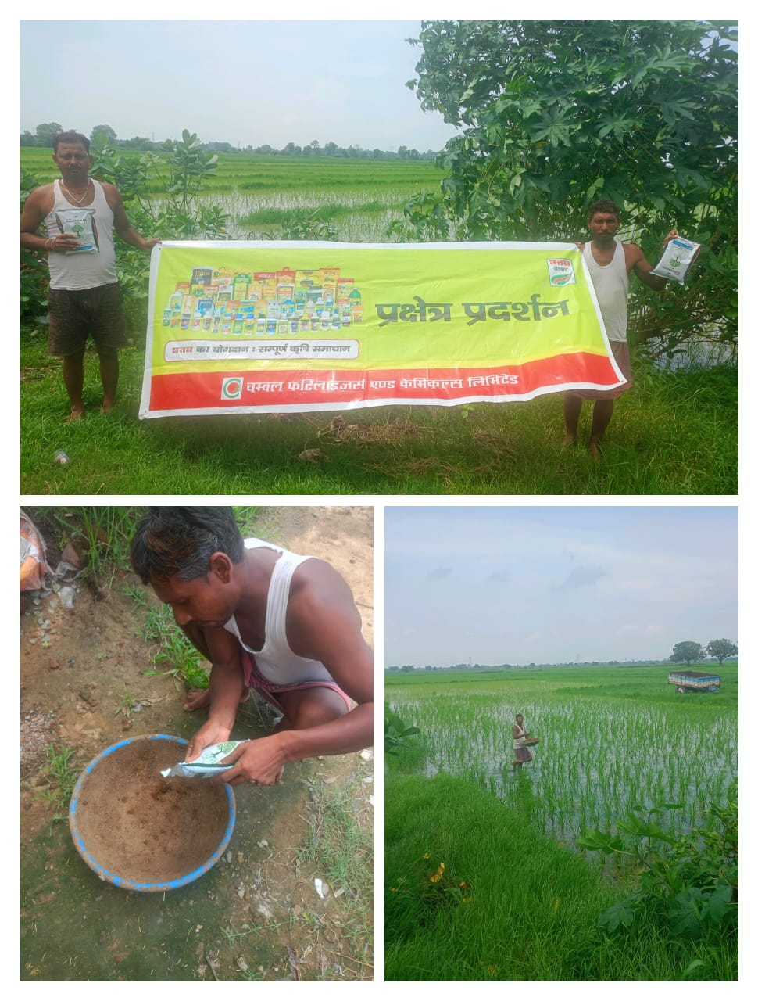

STRR DEMONSTRATION REPORT – 5
Seed to Harvest
Details Of Farmer
Name of Farmers | Triloki kumar
Mobile No. | 85076 21042
Village Name | Tenduni
Block & Tehsil | chenari
District & State | ROHTASH

Field And Crop Detail
Total Acreage(acre) | 15 ACRE
Crops Grown | 15 ACRE
Field Location (Easy approach/road side) | EASY APPROCH
Selected - Crop & Variety | PADDY MTU-7029
Trial Plot Area (KATHA) | 1 acre (INCULDING T1+ T2)
Seed Rate (kg/acre) | 04 KG/acre
Sowing Date | 13.08.2025

Demo Product Name And Dose& Field day detail
Name of Product | SUPERRIZAH
Application Dose (ml/acre) | 2 KG
Date/Time of Application | 13.08.2025

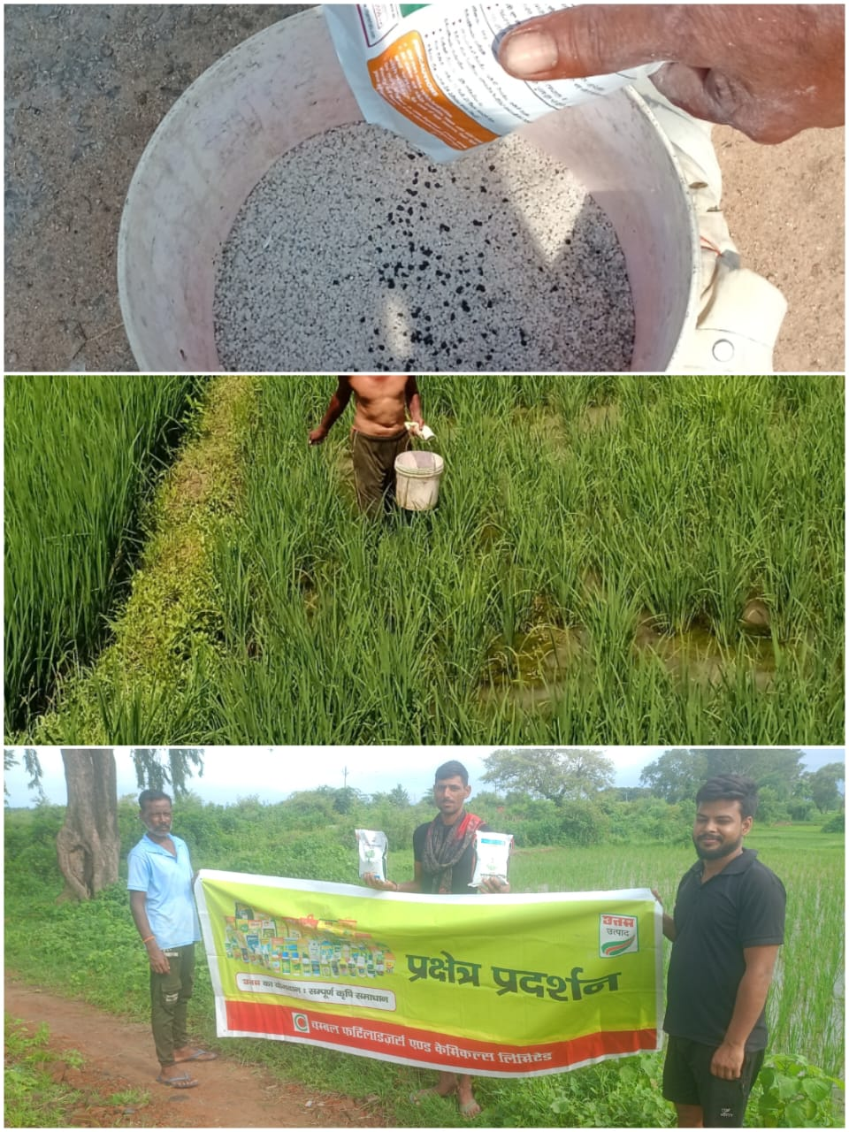

STRR DEMONSTRATION REPORT – 6
Seed to Harvest
Details Of Farmer
Name of Farmers | kalika prasad
Mobile No. | 9631645827
Village Name | Nawadih
Block & Tehsil | Tilouthu
District & State | ROHTASH

Field And Crop Detail
Total Acreage(acre) | 25 ACRE
Crops Grown | 25 ACRE
Field Location (Easy approach/road side) | ROAD SIDE
Selected - Crop & Variety | PADDY MTU-7029
Trial Plot Area (KATHA) | 1 acre (INCULDING T1+ T2)
Seed Rate (kg/acre) | 4 KG/acre
Sowing Date | 19.07.2025

Demo Product Name And Dose& Field day detail
Name of Product | SUPERRIZAH
Application Dose (ml/acre) | 2 KG
Date/Time of Application | 19.07.2025

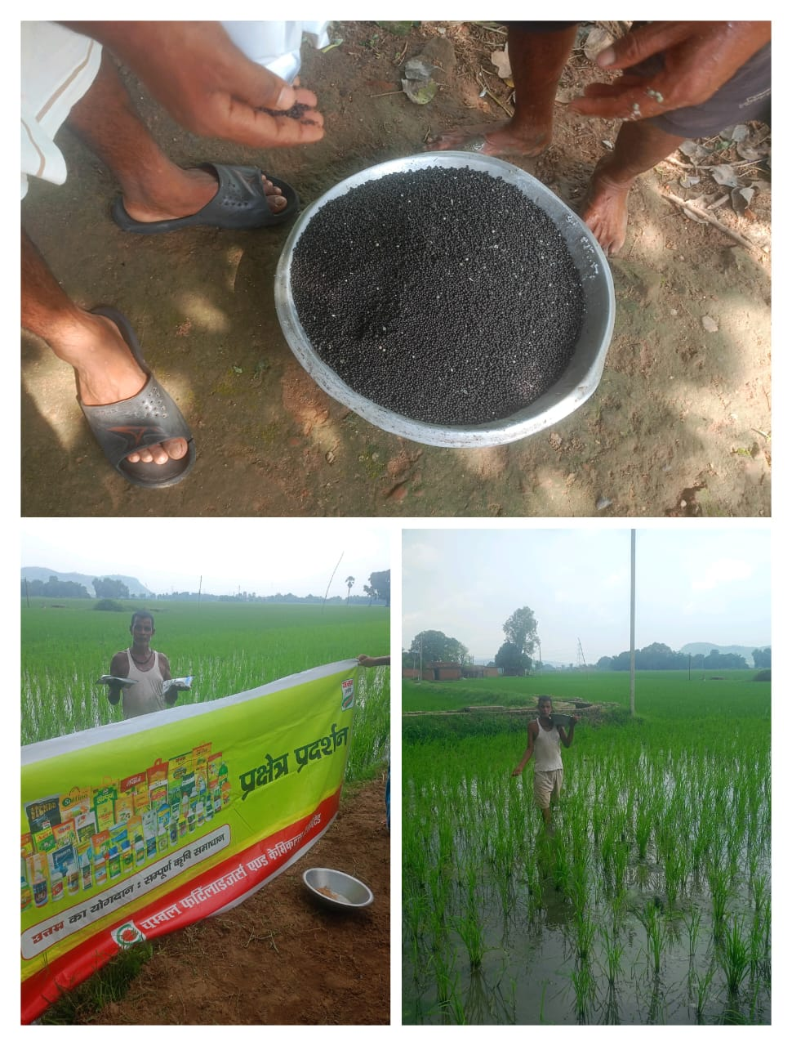

STRR DEMONSTRATION REPORT – 7
Seed to Harvest
Details Of Farmer
Name of Farmers | Sunil kumar shah
Mobile No. | 8084066341
Village Name | Shahpur
Block & Tehsil | chenari
District & State | ROHTASH

Field And Crop Detail
Total Acreage(acre) | 20 ACRE
Crops Grown | 20 ACRE
Field Location (Easy approach/road side) | EASY APPROACH
Selected - Crop & Variety | PADDY MTU-7029
Trial Plot Area (KATHA) | 1 acre (INCULDING T1+ T2)
Seed Rate (kg/acre) | 04 KG/acre
Sowing Date | 06.08.2025

Demo Product Name And Dose& Field day detail
Name of Product | SUPERRIZAH
Application Dose (ml/acre) | 2 KG
Date/Time of Application | 06.08.2025

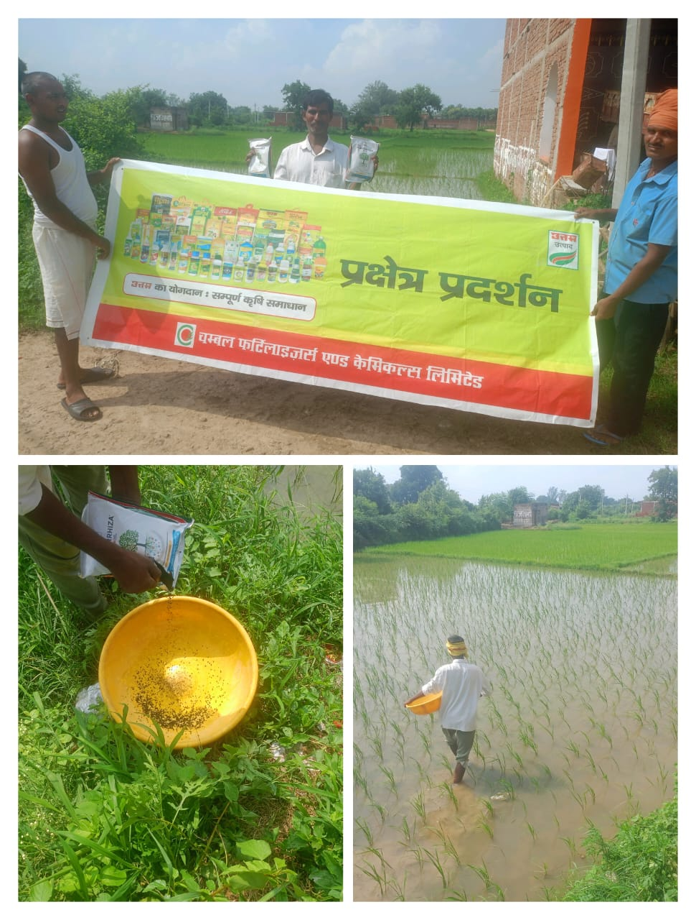

STRR DEMONSTRATION REPORT – 8
Seed to Harvest
Details Of Farmer
Name of Farmers | vedprakash singh
Mobile No. | 9771310742
Village Name | Chanka
Block & Tehsil | Nokha
District & State | ROHTASH

Field And Crop Detail
Total Acreage(acre) | 08 ACRE
Crops Grown | 08 ACRE
Field Location (Easy approach/road side) | ROAD SIDE
Selected - Crop & Variety | PADDY MTU-7029
Trial Plot Area (KATHA) | 1 acre (INCULDING T1+ T2)
Seed Rate (kg/acre) | 04 KG/acre
Sowing Date | 12.08.2025

Demo Product Name And Dose& Field day detail
Name of Product | SUPERRIZAH
Application Dose (ml/acre) | 2 KG
Date/Time of Application | 12.08.2025
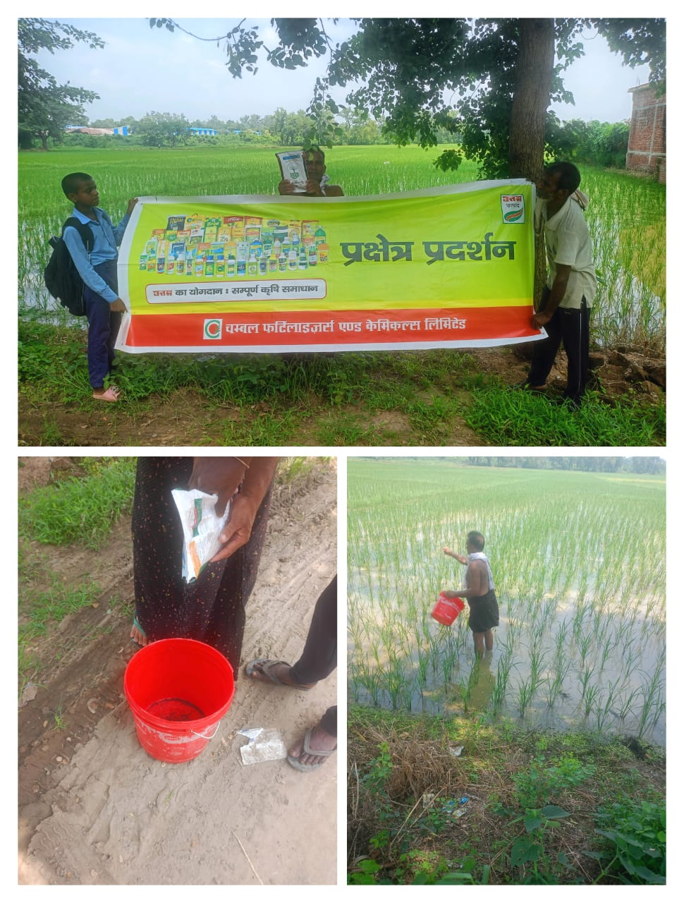

STRR DEMONSTRATION REPORT – 9
Seed to Harvest
Details Of Farmer
Name of Farmers | Jitendra singh
Mobile No. | 9534796136
Village Name | Huruka
Block & Tehsil | Tilouthu
District & State | ROHTASH

Field And Crop Detail
Total Acreage(acre) | 05 ACRE
Crops Grown | 05 ACRE
Field Location (Easy approach/road side) | EASY APPROCH
Selected - Crop & Variety | PADDY MTU-7029
Trial Plot Area (KATHA) | 1 acre (INCULDING T1+ T2)
Seed Rate (kg/acre) | 4 KG/acre
Sowing Date | 11.08.2025

Demo Product Name And Dose& Field day detail
Name of Product | SUPERRIZAH
Application Dose (ml/acre) | 2 KG
Date/Time of Application | 11.08.2025

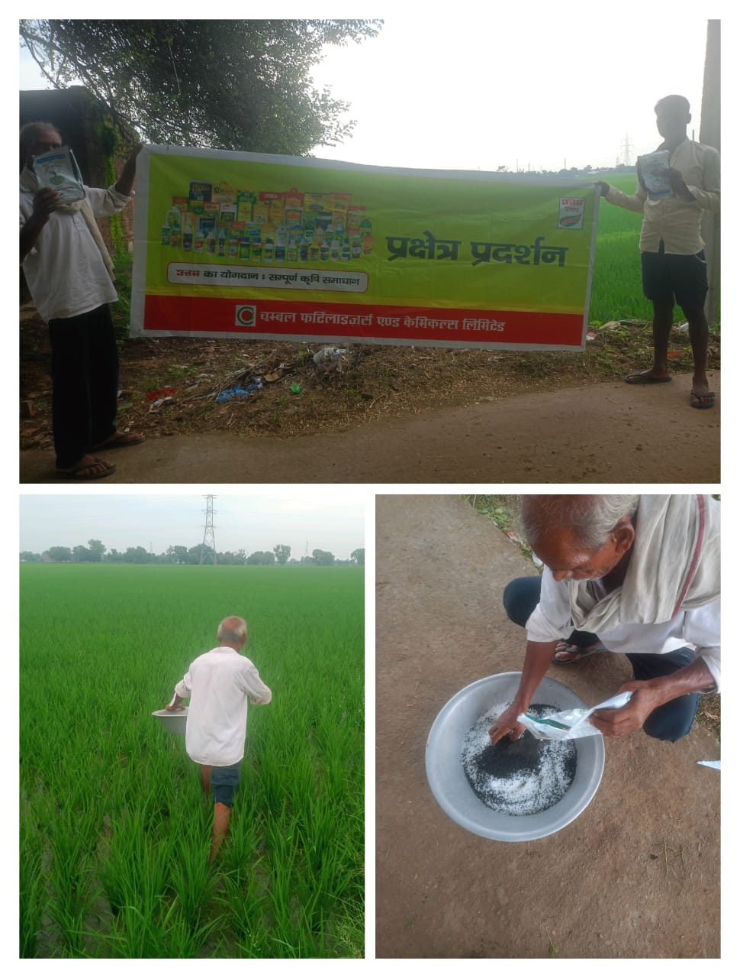

STRR DEMONSTRATION REPORT – 10
Seed to Harvest
Details Of Farmer
Name of Farmers | Jhapsi Yadav
Mobile No. | 8757299933
Village Name | Baradih
Block & Tehsil | Tilouthu
District & State | ROHTASH

Field And Crop Detail
Total Acreage(acre) | 8 ACRE
Crops Grown | 8 ACRE
Field Location (Easy approach/road side) | EASY APPROCH
Selected - Crop & Variety | PADDY MTU-7029
Trial Plot Area (KATHA) | 1 acre (INCULDING T1+ T2)
Seed Rate (kg/acre) | 4 KG/acre
Sowing Date | 05.08.2025

Demo Product Name And Dose& Field day detail
Name of Product | SUPERRIZAH
Application Dose (ml/acre) | 2 KG
Date/Time of Application | 05.08.2025
